Big Springs willow protection from grazing but not wildlife (note that extensive cover for wildlife is not nearby and highway is nearby, possibly resulting in less wildlife use than may occur on Beyeler property).

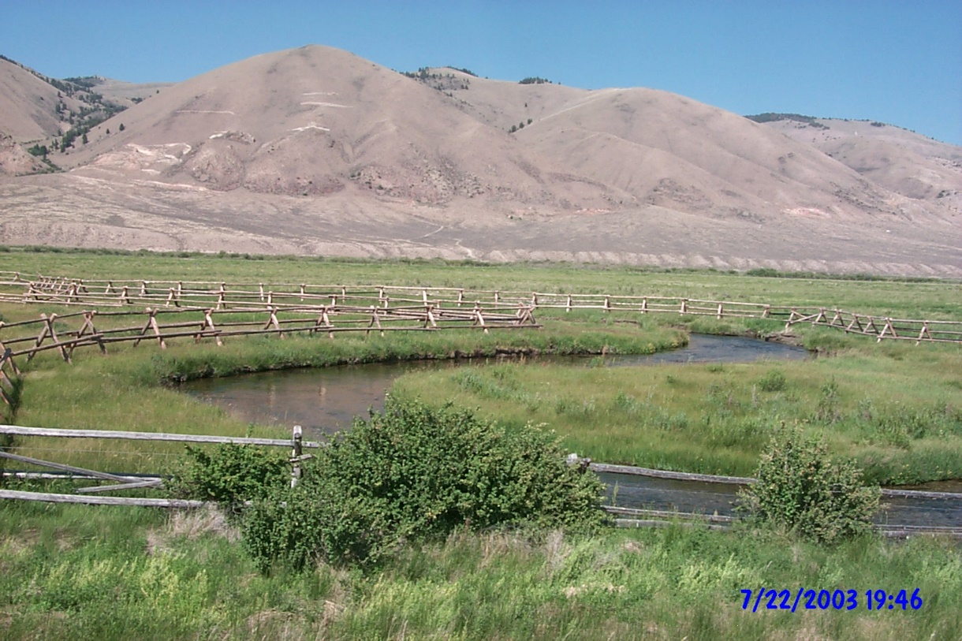

22 July 2003 - Big Springs Creek at Photopoint #2 Lower Nebaur from Hwy 28 at Mile 93.2. View direction Northwest. Installed 2002 (44.71286 -113.41167).

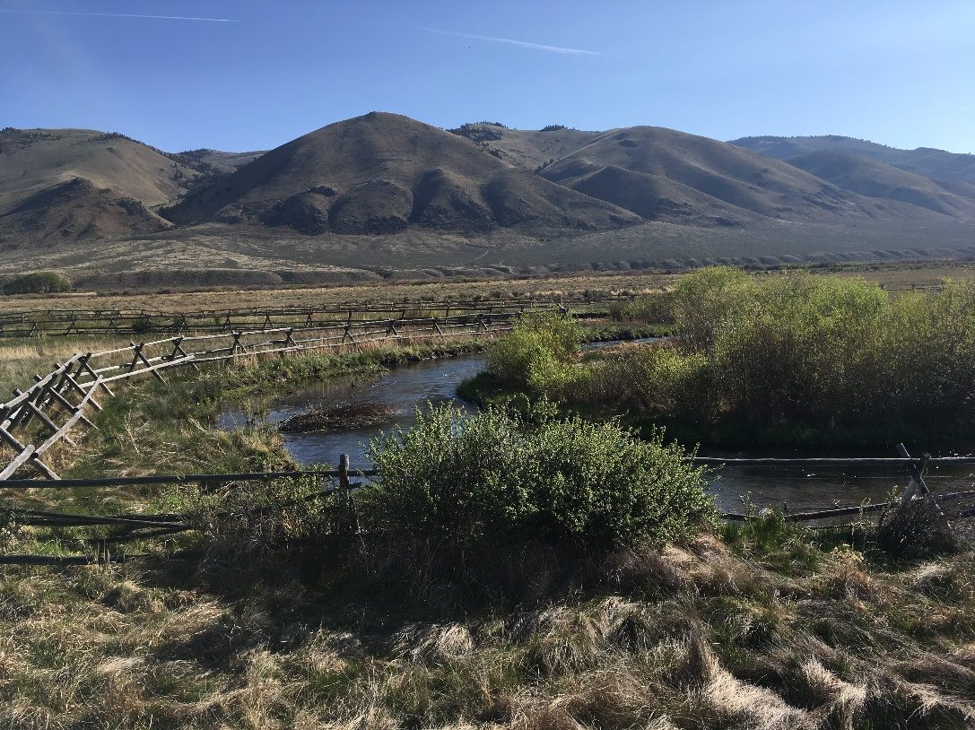

30 May 2019 - Big Springs Creek at Photopoint #2 Lower Nebaur from Hwy 28 at Mile 93.2. View direction Northwest. Installed 2002 (44.71286 -113.41167).

Beyeler Ranch willow tour with Chris Hoag

On 30 May 2019, Chris Hoag (Hoag Riparian & Wetland Restoration, LLC), who has worked extensively on willow restoration throughout his career, went on a field tour of the Merrill Beyeler Ranch at Leadore with people working on habitat restoration on that ranch. During the tour, Chris Hoag addressed the questions in the following list. His answers were compiled and he reviewed, edited, and approved the following answers to the questions. The objective of the tour was to develop an understanding of those factors that affect willow survival, growth, and regeneration in poorly-drained, high-elevation alkali/sod meadow project area near Leadore Idaho.

1. What did the willow community in this area likely look like historically?
   * Likely not solid willows. Rough guess at willow coverage was between 60 and 80%. The willow stands would be interspersed with wet meadows, shallow wetlands, beaver ponds, and upland vegetation (Black Greasewood, Sagebrush, and/or rabbitbrush) on the higher mounds. However, beaver dam cycles would contribute to extensive establishment of willows.
2. What mechanisms were likely used to change the willow community to the current state?
   * Grazing, beaver trapping, water withdrawal, chemicals, mechanical removal.
3. What factors are currently affecting willow recovery?
   * Water withdrawal, wildlife browse, competition from sod grasses (rushes and sedges), alkaline soils.
4. How long can we expect willow recovery to take with planting under various scenarios?
   * 1. No action – current grazing pressure (70 yearlings 1 June – 1 August)
        + A long time (The grazing strategy and timing work for willow growth, but ongoing wildlife browse will continue to hinder willow recovery). Cattle can be used as a tool to keep the sod grasses and weeds down. Intense management will be needed when cattle are there to keep them off the willows. As beaver start to come in, they will affect the willow recovery depending upon numbers.
     2. Temporary cattle grazing elimination
        + A long time.
     3. Temporary wildlife browse elimination
        + 10 – 15 years
     4. Temporary removal of both cattle and wildlife
        + 10 – 15 years
5. How much, if any, would planting potted or pole cutting willows help?
   * Because of the sod, willows are going to have a hard time becoming established. Planting potted plants in areas where they are needed to anchor banks is important for recovery. Planting willows, either poles or pots, should not be done in wet meadow locations.
6. Are pole cuttings recommended in this area (soils)?
   * Yes, most willows like fine textured soils. They will grow in coarse textured too. NOTE: well drained soils are necessary for cottonwoods, but willows will grow in poorly drained fine textured soils (wet feet). Some species, for example. Coyote willow, prefer coarse soils although they will grow in fine textured soils too.
   * Potted willows need to have ¼ of the roots in water at low water and should be planted at least 6 inches into the gravel below the fine soil and sod. This is especially true when planting along outside meanders in moist soils without an aerobic layer. It is ok to bury both the potted portion of the plant and some of the plant stem itself in order to get 6 inches of the roots into gravel. Trim the apical bud (the longest stem) so that the willow will distribute energy to the remaining portion of the plant and the roots.
7. Over what period of time does temporary removal of cattle and/or wildlife need to be done to allow for willow recovery?
   * Beyeler is using the right strategy to graze cattle in the riparian area and therefore, if this strategy continues, there is no need to eliminate grazing to achieve willow recovery. This strategy is to put the cattle in the pasture early (1 June) and graze while the protein in the grass is high. In mid to late summer, protein in the grass decreases and increases in the willows. This causes the cattle to shift from grazing grass to eating willows. Cattle need to be removed from the riparian pasture before this switch happens. The switch in protein levels can vary from place to place and even from year to year in one place. However, it is always possible to tell when it has switched, because cattle will begin eating willows.
8. Is there a certain height willows attain where they are not vulnerable to cattle or wildlife?
   * Apical bud needs to be above 4 feet for cattle and most wildlife, 6 feet for moose.
9. If cattle grazing is conducted, when is the best time to do so to minimize impacts to willows?
   * See answer on #7 above.
10. How should willow planting be done to maximize survival and growth of plants?
    * Use deep rooted pots in wet areas without an aerobic layer and get at least 6 inches of the roots into the gravel under the fines and silt. See answer to #6 above. Live cuttings can be used in most places. They will allow planting deeper to get into the lowest watertable of the year. Pole plantings are used with other bioengineering treatments.
11. Would inserting long pole cuttings that can penetrate through the 2-4 foot thick alkali silty clay layer into gravels below improve willow growth.
    * Yes, they are one of the best planting methods in these situations. I recommend ¾ inch diameter cuttings with 3-5 cuttings in each hole.
12. Could the low oxygen condition of the upper soil still affect willow growth somehow when the willows can root in the gravel?
    * Willows cuttings need about 4 inches of soil at the top that is not saturated. Oxygen comes from this area as well as from the gravels below the soil. On the Beyeler Ranch, willows need both the dry soil on top and to have their roots into the gravel on the bottom. They will grow in saturated soils as long as they have the aerobic layer on top. The gravel adds some oxygen to help the growth.
13. What other native woody vegetation might have potential for success in this location?
    * Dogwood, currant, rose, gooseberry, birch, alder
14. If small exclosures are used instead of complete project area exclosures, in what types of areas should exclosures be used?
    * Maximize number of plants enclosed with minimal fencing materials, make sure plants are at least 2 feet from the edge of the panels so that wildlife doesn’t reach over, use hog panels that are a minimum 4-5 ft high. Can also use horse fence (gal 2x4 inch holes) because you are able to bend to encircle plants (use minimum 3 ft diameter) and they keep beaver out burry a couple of inches in the ground in high beaver number areas). Use 2-3 metal T-posts to hold up the enclosures so the big game animals can’t push them over.
15. Can willow recovery of the riparian area be accomplished with small exclosures?
    * Willow recovery can be accomplished this way.
16. Are there other things that can be done to speed willow recovery?
    * Willow clumps can be used to get the recovery going faster if a good source is found.
17. Would the use of Plant Skydd negate the need for a wildlife exclusion fence and might it work on cattle too?
    * Mixed results have been seen with use of Plant Skydd. Sometimes it seems to work and sometimes not. Apply in the spring and fall. Typically, deer repellents should be backed up with something else like limited exclosures. PlantSkydd will not help with beaver.
18. Is Plant Skydd is more or less cost-effective than fencing?
    * Not sure on cost effectiveness, but is less effective. Cost/Benefit ratio for using just deer repellents is not very high.
19. Could Plant Skydd be applied by plane?
    * Not sure.
20. Do cattle affect willows by other means than just browsing on them?
    * Compaction can occur but is not a problem given the soils present (except areas that are saturated) and the current grazing regime.
21. What other native woody vegetation might have great potential for success in this location?
    * See #13.

Other Notes –

* Exclosures need to be 4 feet tall plus snow depth (if snow gets hard enough for wildlife to stand on top of it).
* All newly planted potted willows need to be inside an exclosure as they get disproportionally more browse than wild willows.
* Cuttings for growing potted willows should come from the general area.
* Plant cuttings in 18 inch pots and leave 4-10 feet of willow stem above the pot. Then bury well, including some of the plant stem to get roots at least 6 inches into gravel. Then clip the apical bud.
* Coyote willow is usually not grazed as much as other species of willows. Birch is a species that is not very palatable to many species. It is found along rivers, streams, springs and moist locations on a variety of gravelly, cobbly to medium textured soils.
* Pacific or whiplash willows grow tall enough to get well above the browse line.
* Willows on Beyeler include Geyer, Booth, Drummond, Whiplash, and Coyote
* Pole cuttings should be 3’ long with 2’ in ground and 1’ above. Minimum diameter should be ¾ inch and average should be 1-2 inches in diameter (species dependent)
* Shingled revetments on eroding banks work well especially if they include vertical willow bundles and pole cuttings.
* Try to prioritize areas based on “bang for the buck” i.e. protecting established willows from browse trumps planting pots.
* In Breann’s project we saw volunteer willows that were naturally seeded in the silt between placed sod. The silt between the mats was lower than the “flood-plain” and so was easily inundated (but didn’t remain submerged), which resulted in the willow establishment.

**Plants should be placed in three Riparian Planting Zones. In the Bank zone, Coyote Willow (*Salix exigua*), Yellow Willow (*Salix lutea*), and Redosier Dogwood (*Cornus sericea*). In the Overbank zone (floodplain), Booth’s Willow (*Salix boothii*), Drummond’s Willow (*Salix drummondiana*), Geyer’s Willow (*Salix geyeriana*), Pacific or Whiplash Willow (*Salix lucida ssp lasiandra*), Peachleaf Willow (*Salix amygdaloides*), Thin leafed Alder (*Alnus incana ssp tenuifolia*), Water or Black Birch (*Betula occidentalis*), and Redosier Dogwood (*Cornus sericea*). In the transitional and upland zone, Black Cottonwood (*Populus trichocarpa*), Pacific or Whiplash Willow (*Salix lucida ssp lasiandra*), Common Chokecherry (*Prunus virginiana*), Golden Currant (*Ribes aureum*), Water or Black Birch (*Betula occidentalis*), Syringa or Lewis Mockorange (*Philadelphus lewisii*), and Thin leafed Alder (*Alnus incana spp. tenuifolia*).**

**Planting methods include:**

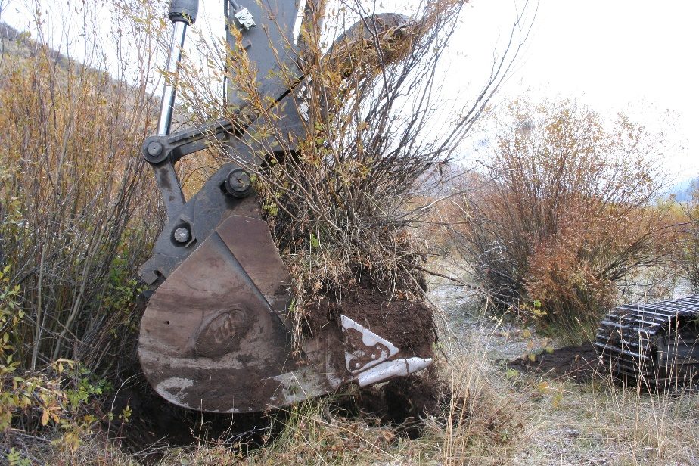**Live willow clumps: Harvesting live willow clumps from the floodplain and planting the roots down to the water table. ¼ of the roots should be in the lowest water table of the year.**

* **Live brush spurs made from willow cuttings packed into a box outline**

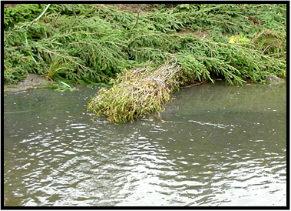

* **Small tree revetments constructed out of Juniper or Spruce used as bank protection, velocity reduction, sediment accumulation, and fish habitat improvement.**

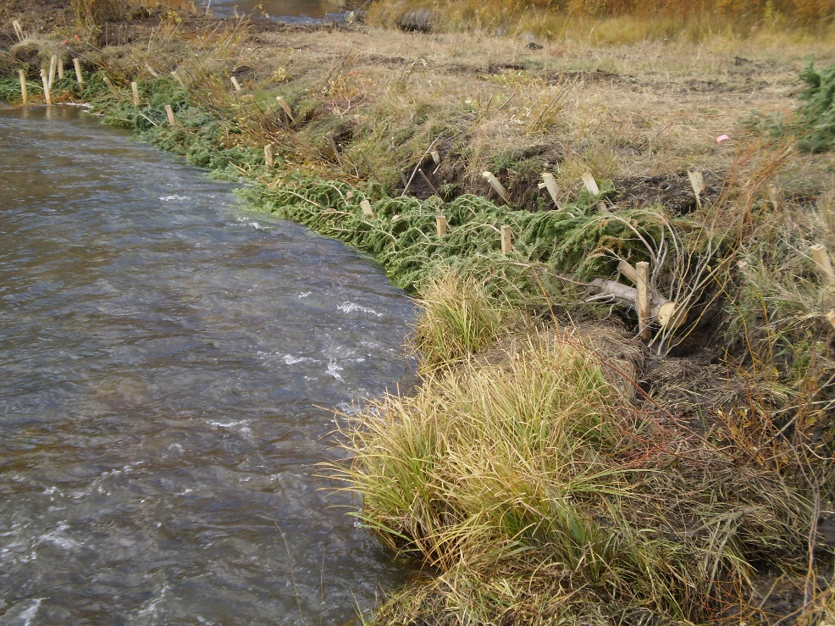

* **A riparian buffer strip of woody vegetation consisting of willow, birch, cottonwood, etc. should be considered for planting on both sides of the creek on the upper bank and terrace.**

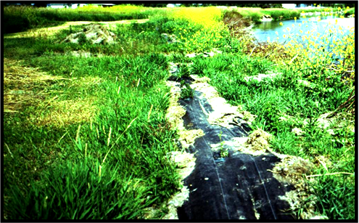

* **Large pot planting: taking large pots and planting them down to the water table.**

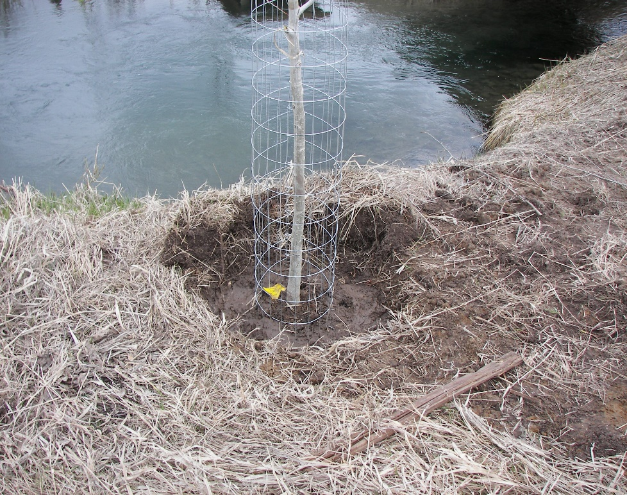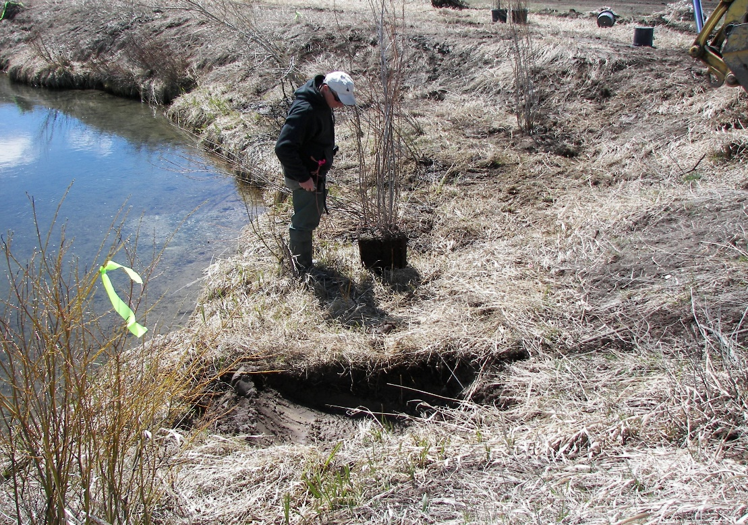

* **Vertical Bundles: Planting live cuttings bundles of 3-5 dormant unrooted cuttings in the bank.**

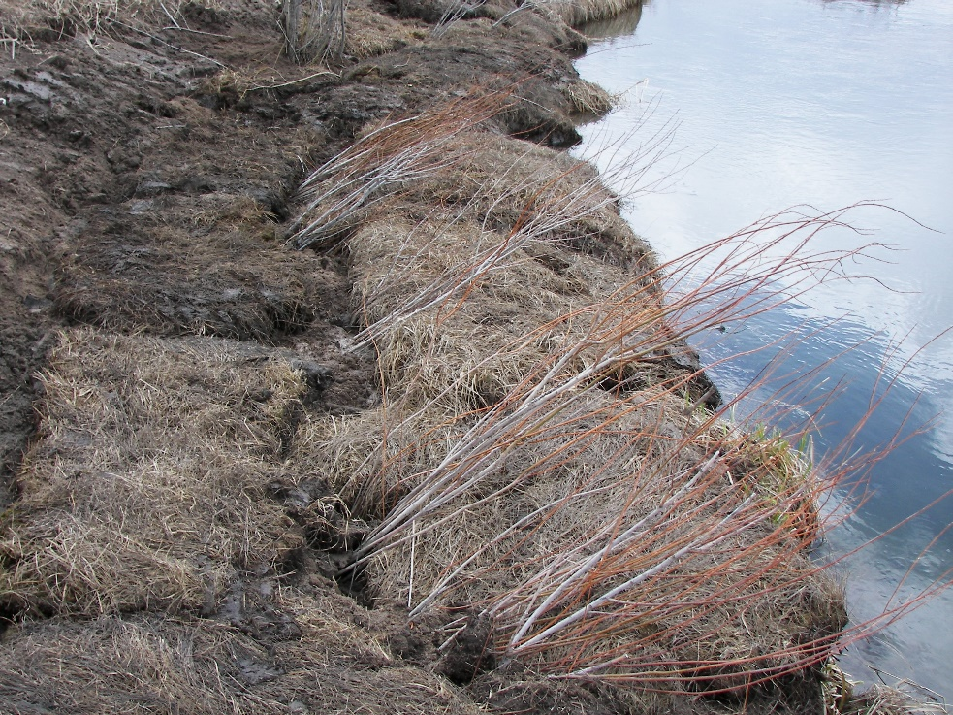

* 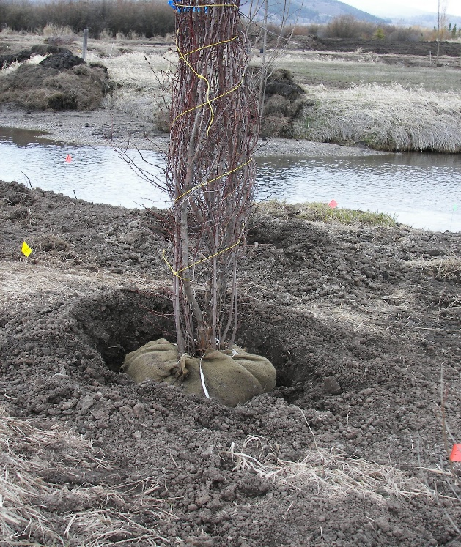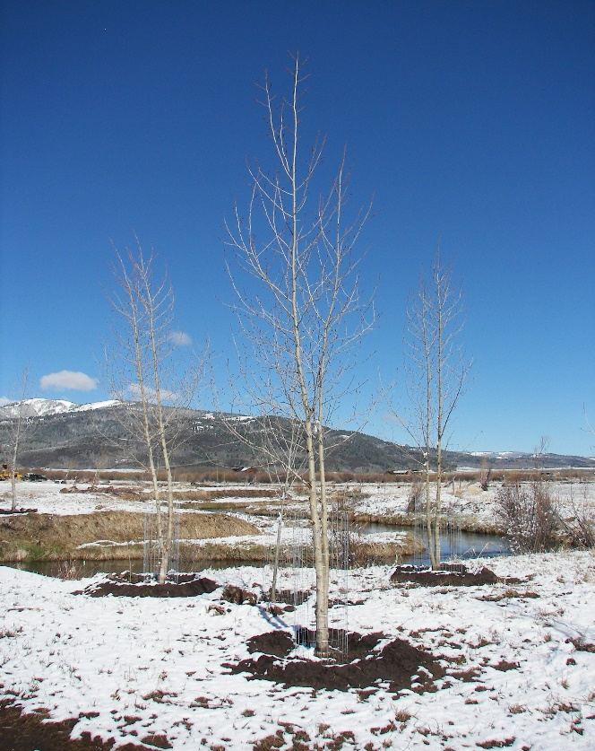**Balled and Burlap trees: large clumps of trees are dug and wrapped in burlap to protect the roots. Burlap is removed before putting the tree clump in the ground.**
* **Wetland sod mats: Sod mats and harvested sod from native stands of wetland plants.** 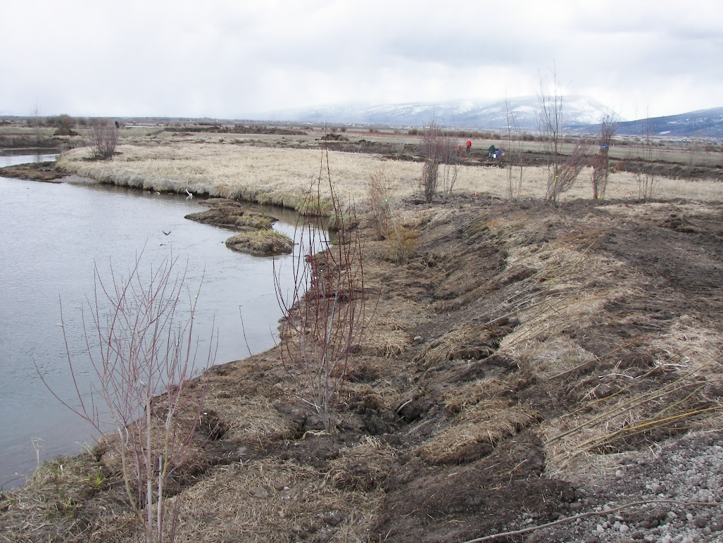
* **Live cuttings: live dormant unrooted cuttings are planted down to the water table with a Waterjet Planter.**

